

**T.C. ISTANBUL AREL UNIVERSITY**

**FACULTY OF ENGINEERING AND ARCHITECTURE**

**COMPUTER ENGINEERING**

**SYSTEM ANALYSIS AND DESIGN**

**FINAL PROJECT**

**PROJECT MANAGER**

**Assoc. Prof. Dr. Farzad Kiani**

**Prepared By**

**AHMET YILMAZ**

**180303014**

[**https://1drv.ms/u/s!AjjdKq9gxURbgXGMhpHnlPS85-1W?e=AvdGzc**](https://1drv.ms/u/s!AjjdKq9gxURbgXGMhpHnlPS85-1W?e=AvdGzc)

**ISTANBUL, 2021**

**CONTENT**

1.Project Description 3

2.1.Vision 3

2.2.Mission 3

3.Organization Schema 3

4.Task Lists 4

5.Requirements (Functional and Quality) 6

5.1.Functional Requirements 6

5.2.Quality Requirements 6

6.Scenarios - One scenario for each task 7

7.Usecase Diyagram 11

8.SWOT Table 12

9.Income and Expense Statement 12

10.MS Project 14

11. Use Case Realization 15

12. Squence Diagrams 15

13. EERD and UML Diagrams 18

# 1.Project Description

Football and basketball are among the most watched sports in every region of the world. The most important entertainment of people are these matches and to bet on matches. In this project, people can access it very quicly using the program instead of searching for individual matches that have already been played or will be played. At the same time, we analyze the matches that have been played for them and give them the chance to access statistical data whenever they want.

https://1drv.ms/u/s!AjjdKq9gxURbgXGMhpHnlPS85-1W?e=YJK7px

## 2.1.Vision

To ensure the trust of people by accurately analyzing the most followed sports branches all over the world and to be the first application that everyone always trusts in our knowledge and efforts and to be the first application that people will open and look at when it comes to football and basketball.

## 2.2.Mission

Making accurate and reliable analysis and sharing

by using correct and reliable sources.

# 3.Organization Schema

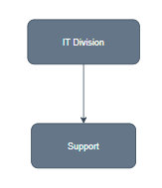

**Figure 1. Organization Schema Level 1**

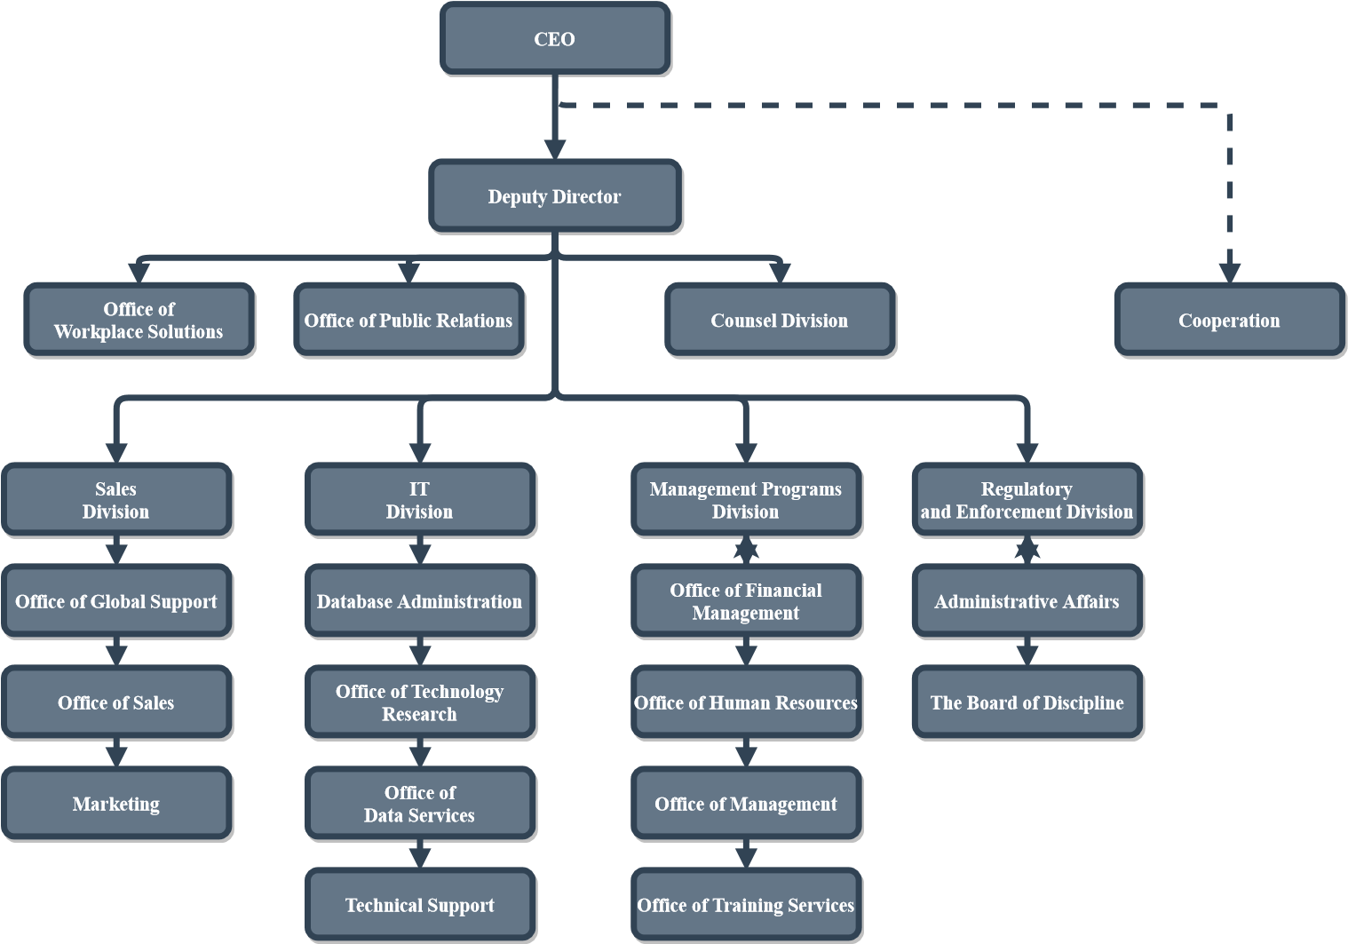

**Figure 2. Organization Schema Level 2**

# 4.Task Lists

**CEO** Company founder, partner or owner

**Deputy Director**

* Assistant Director

**Office of Workplace Solutions**

* It is a mediator for the employer and the employee in solving the problems that may happen in the workplace.

**Office of Public Relations -** prbettinganalysis@gmail.com

* It undertakes to improve the image and reputation of the institution.
* It ensures healthy communication with the target audience.

**Counsel Division -** generalbettinganalysis@gmail.com

* Coordinates customer and company relations

**Sales Division -** salesbettinganalysis@gmail.com

**Office of Global Support**

* It helps people if there is a problem after selling and gets feedback from people after selling as a after selling service

**Office of Sales**

* Manage selling the product

**Marketing**

* Researching the value characteristics of the product to be marketed by doing market research

**IT Division -** softwarebettinganalysis@gmail.com

**Database Administration**

* It manages any database requests that will or may occur from the customer

**Office of Technology Research**

* It provides research for new technologies that may come or may be needed from the customer.

**Office of Data Services**

* It provides the data source used in the system

**Technical Support**

* It solves technical problems that will come from the customer or in case of need

**Management Programs Division -** managementbettinganalysis@gmail.com

**Office of Financial Management -** financialbettinganalysis@gmail.com

* It carries out monetary policy and purchasing when needed

**Office of Human Resources**

* Human Resources Management

**Office of Management**

* It provides managed coordination of all departments

**Office of Training Services**

* to provide a new system to be used or the training policy of someone to start working

**Regulatory and Enforcement Division** – administrationbettinganalysis@gmail.com

**Office of Regulatory Policy**

* to fulfill the legal obligations of the data used or the stored user data

**Administrative Affairs**

* providing and managing administrative judicial needs

**The Board of Discipline**

* to ensure discipline and enforcing domestic laws

# 5.Requirements (Functional and Quality)

## 5.1.Functional Requirements

Type: E(Event), H(Hidden), O(Optional)

|  |  |  |
| --- | --- | --- |
| Code | Functional Requirements | Type |
| 1-1 | The system must do what program, progress, users need. | E |
| 1-2 | The system must upgrade the live data or the match fixtures. | E |
| 1-3 | The system should save and open data. | O |

**Table 1. Admin Usecase FR**

|  |  |  |
| --- | --- | --- |
| Code | Functional Requirements | Type |
| 2-1 | The system must fınd data that user needs. | E |
| 2-2 | The system should be save user’s favorites fixture. | O |
| 2-3 | The system should be reached user’s requests | O |
| 2-4 | The system should have the ability to open / close an account | E |

**Table 2. User Usecase FR**

## 5.2.Quality Requirements

|  |  |  |
| --- | --- | --- |
| Code | Quality Requirements | Type |
| 1-1 | System needs to respond within 5 seconds | Response time |
| 1-2 | It should work in Windows system | Environment |
| 1-3 | It should be a simple and understandable system | Interface |

**Table 3. System Quality**

# 6.Scenarios - One scenario for each task

|  |  |  |
| --- | --- | --- |
| Use Case Name: | Live Fixture | |
| Scenario: | User wants to view live data or fixture | |
| Triggering Event: | The user wants to view live matches | |
| Brief Description: | The user will interact with system to view live matches. | |
| Actors: | User | |
| Stakeholders: | NaN | |
| Preconditions: | Live data must be taken from API.  It must be work runtime to be live. | |
| Postconditions: | User will be able to view fixture same time.  User will be able to filter teams or laugues.  User will have to login if user wants to follow. | |
| Flow of Activities: | Actor | System |
| 1.User opens system no need to be real user.  2.User can open live or fixture on time.  3.User can see the live data on real time.  4.User can save teams if user registered. | 1.System is initialized.  2.System takes data from API  3.Display data on real time.  4.Check user information. |
| Exception Conditions: | 1.1.User cannot connect to the system  2.1.System cannot take data from api because of authentication.  3.1.UI is not responding, display error message.  4.1.User cannot save teams if user is not registered the system before. | |

**Table 3. Live/Fixture Usecase Scenario**

|  |  |  |
| --- | --- | --- |
| Use Case Name: | Statistics | |
| Scenario: | User wants to view statistics of the teams | |
| Triggering Event: | The user wants to view statistics of teams that they were againts before. | |
| Brief Description: | The user will interact with system to view statistics. | |
| Actors: | User | |
| Stakeholders: | NaN | |
| Preconditions: | Matches were played before must be taken from database.  It must be real data comes from API. | |
| Postconditions: | User will be able to view statistics of teams that user wants.  User will be able to filter teams or laugues.  User will have to login if wants to follow. | |
| Flow of Activities: | Actor | System |
| 1.User chooses teams information  2.Lists the last games of the teams  3.Shows the statistical data of the teams  4.The user saves as a file  5.User favorites teams | 1.System is initialized.  2.System takes data from database  3.Calculate data  4.Get user information  5.Save user favorites |
| Exception Conditions: | 1.1.User cannot connect to the system  2.1.System cannot take data from database because of authentication.  3.1.UI is not responding, display error message.  4.1.If user did not log-in user must login into the system  4.1.1.If user did not register the system before user must register the system  4.2. If user does not remember password user must request to remind password.  5.System is not responding, display error message. | |

**Table 4. Statistics Scenario**

|  |  |  |
| --- | --- | --- |
| Use Case Name: | Download | |
| Scenario: | User wants to download data | |
| Triggering Event: | The system does not have matches that user wants. | |
| Brief Description: | The user will interact with system to download. | |
| Actors: | User - Admin | |
| Stakeholders: | Admin | |
| Preconditions: | The data must be taken from API.  It must be downloaded.  It must be compared the data comes from api to database. | |
| Postconditions: | User will be able to download fixture same time.  User will be able to download teams or laugues.  User will have to login if user wants to download. | |
| Flow of Activities: | Actor | System |
| 1.User enter the download system.  2.User login into the system.  3.User choose the timeline to downloand.  4.User must give the permission.  5.System starts to download data. | 1.System is initialized.  2.User authanticate.  3.System shows the timeline.  4.System wait for the permission.  5.Check user information. |
| Exception Conditions: | 1.1.User cannot connect to the system  2.1.System shows that it must be defined user.  3.1.System sends a request to download pach.  4.1.Support must download needed data.  5.1.Support must be in contact to user. | |
| Use Case Name: | Save Open | |
| Scenario: | User wants to save or open data | |
| Triggering Event: | The system has that user information. | |
| Brief Description: | The user will interact with system to save. | |
| Actors: | User - Admin | |
| Stakeholders: | Admin | |
| Preconditions: | The data must be taken from database.  It must be compared the user information. | |
| Postconditions: | User will be able to save fixture same time.  User will be able to save teams or laugues.  User will have to login if user wants to download. | |
| Flow of Activities: | Actor | System |
| 1.User enter the save system.  2.User login into the system.  3.User choose the teams or league to save.  4.User must give the permission.  5.System starts to save data. | 1.System is initialized.  2.User authanticate.  3.System shows the teams.  4.System wait for the permission.  5.Check user information. |
| Exception Conditions: | 1.1.User cannot connect to the system  2.1.System shows that it must be defined user.  3.1.System sends a request to download pach.  4.1.Support must download needed data.  5.1.Support must be in contact to user. | |

**Table 5. Download-Save/Open Scenarios**

|  |  |  |
| --- | --- | --- |
| Use Case Name: | Support | |
| Scenario: | User wants to request. | |
| Triggering Event: | The system has user like that. | |
| Brief Description: | The user will interact with system to get support. | |
| Actors: | User - Admin | |
| Stakeholders: | Admin | |
| Preconditions: | The data must be taken from API.  It must be downloaded.  It must be compared the data comes from api to database. | |
| Postconditions: | User will be able to support from admin | |
| Flow of Activities: | Actor | System |
| 1.User enter the download system.  2.User login into the system.  3.User choose the timeline to downloand.  4. User must give the permission.  5.System starts to download data. | 1.System is initialized.  2.User authanticate.  3.System shows the timeline.  4.System wait for the permission.  5.Check user information. |
| Exception Conditions: | 1.1.User cannot connect to the system  2.1.System shows that it must be defined user.  3.1.System sends a request to download pach.  4.1.Support must download needed data.  5.1.Support must be in contact to user. | |

**Table 6. Support Scenario**

|  |  |  |
| --- | --- | --- |
| Use Case Name: | SignUp SignIn SignOut | |
| Scenario: | User wants to download data | |
| Triggering Event: | The system does not have matches that user wants. | |
| Brief Description: | The user will interact with system to download. | |
| Actors: | User - Admin | |
| Stakeholders: | Admin | |
| Preconditions: | The data must be taken from database | |
| Postconditions: | User will be able to sign in the system | |
| Flow of Activities: | Actor | System |
| 1.User enter the login system.  2.User SignIn or SignUp into the system. | 1.System is initialized.  2.User authanticate. |
| Exception Conditions: | 1.1.User cannot connect to the system  2.1.System shows that it must be defined user. | |

**Table 7. SignUp-Sign-In-SingOut Scenario**

# 7.Usecase Diyagram

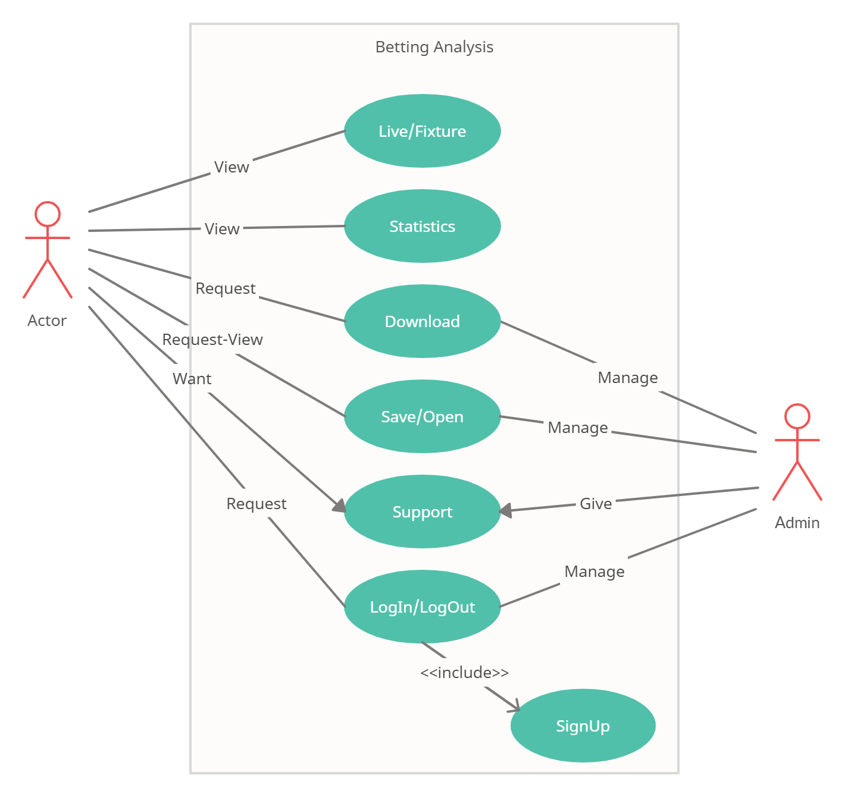

**Figure 3. Usecase**

# 8.SWOT Table

|  |  |  |
| --- | --- | --- |
|  | Helpful | Harmful |
| Internal | 1. Free APIs 2. Not too much workforce 3. Low cost 4. Known by all people 5. Appealing ability (domestic and foreign) 6. Access from all platforms (web, mobile etc.) 7. Low update cost | 1. When APIs is disable 2. If APIs are not free it can be high cost 3. Similar products on the market |
| Strengths | Weaknesses |
| External | Oppotunities | Threats |
| 1. Peope like football 2. Find investors 3. Corporate investors not entering the sector | 1. Betting is forbidden |

**Table 8. SWOT**

# 9.Income and Expense Statement

|  |  |  |  |  |
| --- | --- | --- | --- | --- |
| **N** | **Description** | **Unit Price** | **Total** | **G. Total** |
| 1 | Software | 2000$ | 8000$ | 96.000 |
| 2 | APIs | 40$ | 80$ | 80 |
| 3 | Data Client | 350$ | 350$ | 4200 |
| 4 | Technical Service | 1300$ | 1300$ | 15600 |
| 5 | Mail Order | 600$ | 600$ | 600 |
|  |  |  | **Total:** | **116.480$** |

**Table 9.1. Expense Statement**

|  |  |  |  |  |
| --- | --- | --- | --- | --- |
| **N** | **Description** | **Unit Price** | **Total** | **G. Total** |
| 1 | Software | 5$ Per a User | 50.000$ | 600.000 |
| 2 | APIs | Free- | - |  |
| 3 | Data Client | Free- | - |  |
| 4 | Advertisement | 1$ Per a Click | 10.000$ | 120.000 |
| 5 | Mail Order | Licence 50$ | 50$ | 600 |
| 6 | Mail Box | Free- | - |  |
| 7 | Sponsored | 100$ | 1200$ | 14.400 |
| 8 | Investor | 2000$ Per a Sofware | 8.000$ | 96.000 |
|  |  |  | **Total:** | **831.000$** |

**Table 9.2. Income Statement**

|  |  |  |  |  |
| --- | --- | --- | --- | --- |
| **N** | **Description** | **Unit Price** | **Total** | **G. Total** |
| 1 | Software | - | - | - |
| 2 | APIs | 30$ | -30$ | -360$ |
| 3 | Data Client | 50$ | -50$ | -600$ |
| 4 | Advertisement | 1$ Per a Click | 500$ | 6.000$ |
| 5 | Mail Order | Free- | - | - |
| 6 | Mail Box | Free- | - |  |
| 7 | Sponsored | - | - | - |
| 8 | Investor | - | - | - |
|  |  |  | **Total:** | **5.040$** |

**Table 9.3.Income and Expense Statement**

# 10.MS Project

|  |  |  |  |  |
| --- | --- | --- | --- | --- |
| **Görev Adı** | **Süre** | **Başlangıç** | **Bitiş** | **Öncüller** |
| **Betting Analysis** | **76 gün?** | **Pzt 1.03.21** | **Pzt 14.06.21** |  |
| Start Project | 1 gün | **Pzt 1.03.21** | **Pzt 1.03.21** |  |
| **Literature Review** | **15 gün?** | **Pzt 1.03.21** | Cum 19.03.21 |  |
| Find data provider | 5 gün | Pzt 1.03.21 | Cum 5.03.21 |  |
| Project structural integrity | 4 gün | Pzt 8.03.21 | Per 11.03.21 | 3 |
| Preparing Shematics | 10 gün | Pzt 8.03.21 | Cum 19.03.21 | 3 |
| Market Research | 5 gün | Pzt 1.03.21 | Cum 5.03.21 |  |
| **Start Coding Project** | **20 gün** | **Pzt 8.03.21** | **Cum 2.04.21** |  |
| Preparing Tables | 10 gün | Pzt 8.03.21 | Cum 19.03.21 | 3 |
| Establishing Relationships of Entities | 15 gün | Pzt 8.03.21 | Cum 26.03.21 | 3 |
| Pattern Layer Architecture | 20 gün | Pzt 8.03.21 | Cum 2.04.21 | 3 |
| **Data Layer** | **20 gün** | **Pzt 22.03.21** | **Cum 16.04.21** |  |
| Database Management | 20 gün | **Pzt 22.03.21** | **Cum 16.04.21** | 8 |
| Download and Save Data | 10 gün | Pzt 29.03.21 | Cum 9.04.21 | 9 |
| API Connecting with DB | 2 gün | Pzt 12.04.21 | Sal 13.04.21 | 13 |
| **Entity Layer** | **11 gün** | **Pzt 29.03.21** | **Pzt 12.04.21** |  |
| Creating the Class Structures | 10 gün | Pzt 29.03.21 | Cum 9.04.21 | 9 |
| EF JSON Extensions | 6 gün | Pzt 5.04.21 | Pzt 12.04.21 | 10 |
| **Business Access Layer** | **51 gün** | **Pzt 29.03.21** | **Pzt 7.06.21** |  |
| Repository Pattern Layer | 20 gün | Pzt 5.04.21 | Cum 30.04.21 | 10 |
| Service Layer | 18 gün | Pzt 5.04.21 | Çar 28.04.21 | 10 |
| Connecting User Interface with Entities | 14 gün | Pzt 29.03.21 | Per 15.04.21 | 9 |
| API-DB-UI Connection | 20 gün | Pzt 3.05.21 | Cum 28.05.21 | 19;20;21 |
| Authorization | 6 gün | Pzt 31.05.21 | Pzt 7.06.21 | 22 |
| **Presentation Layer** | **11 gün?** | **Pzt 31.05.21** | **Pzt 14.06.21** |  |
| Creating User Interface | 1 gün? | Pzt 31.05.21 | Pzt 31.05.21 | 22 |
| User Supporting | 5 gün | Sal 8.06.21 | Pzt 14.06.21 | 23 |
| **Checking Project** | **2 gün?** | **Sal 1.06.21** | Çar 2.06.21 |  |
| Bug Fixed | 1 gün | Sal 1.06.21 | Sal 1.06.21 | 25 |
| Reporting | 1 gün? | Çar 2.06.21 | Çar 2.06.21 | 28 |

**Table 10. MS Project**

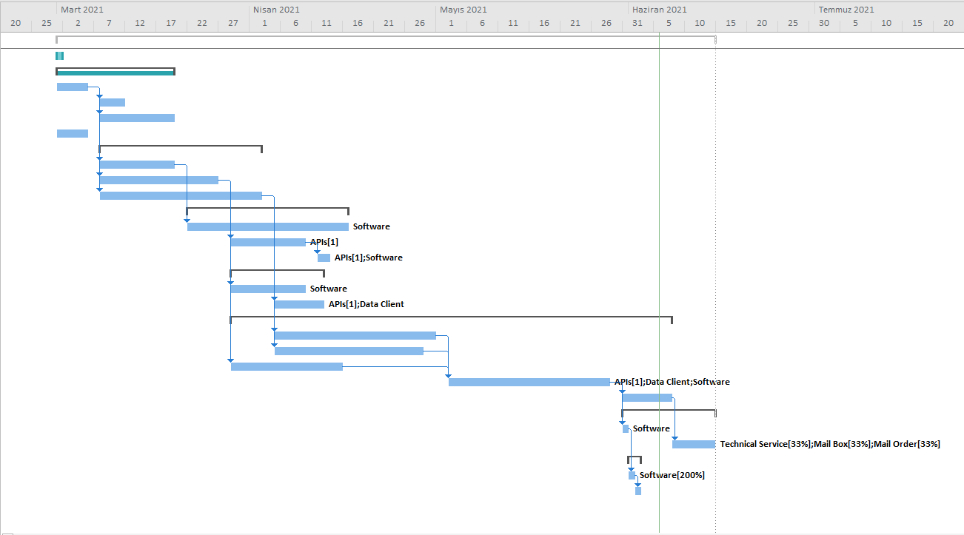

**Schema 1. Gantt**

# 11. Use Case Realization

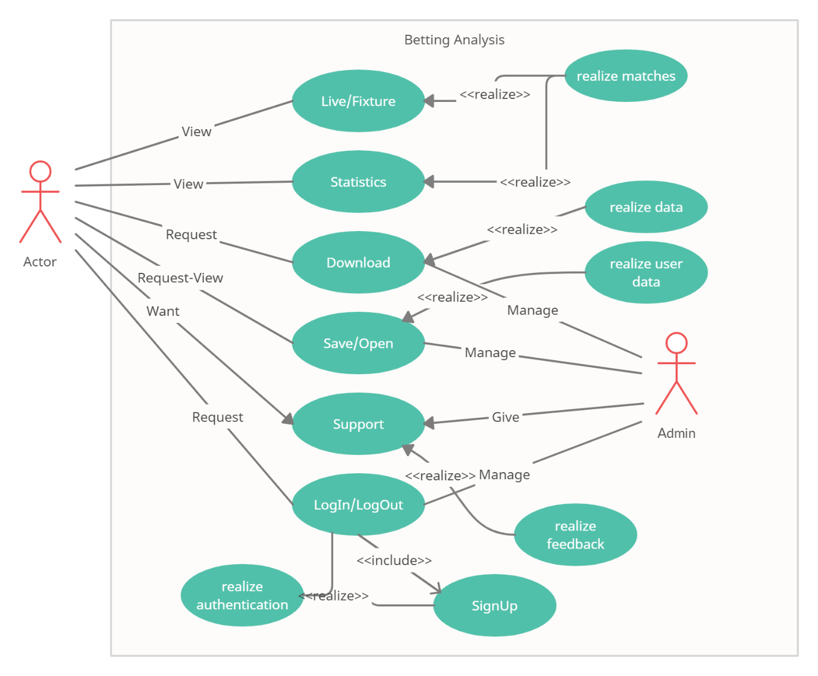

**Figure 4. Usecase Realization**

# 12. Squence Diagrams

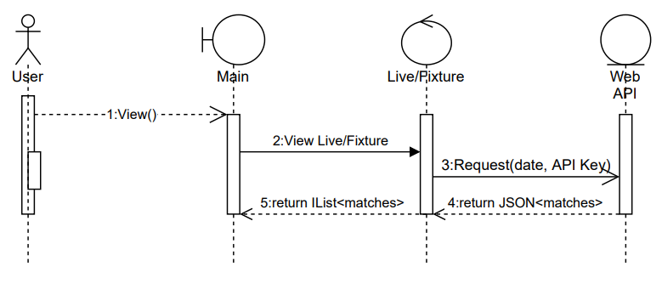

**Figure 5. Live Fixture Sequence Diagram**

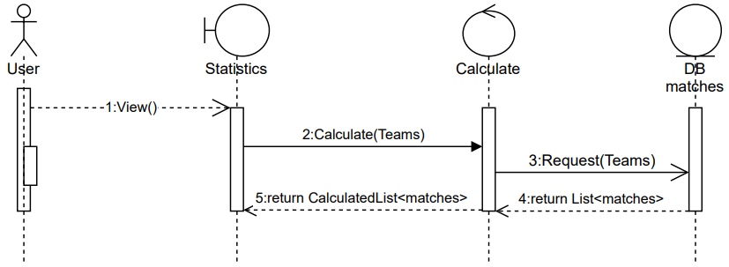

**Figure 6. Statistics Sequence Diagram**

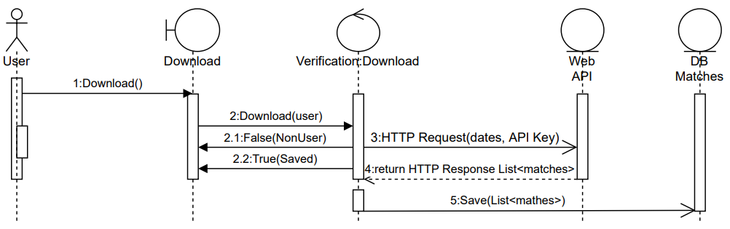

**Figure 7. User Download Sequence Diagram**

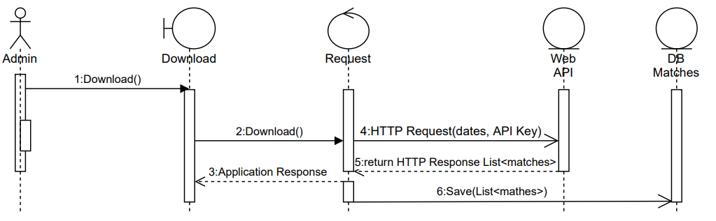

**Figure 8. Admin Download Sequence Diagram**

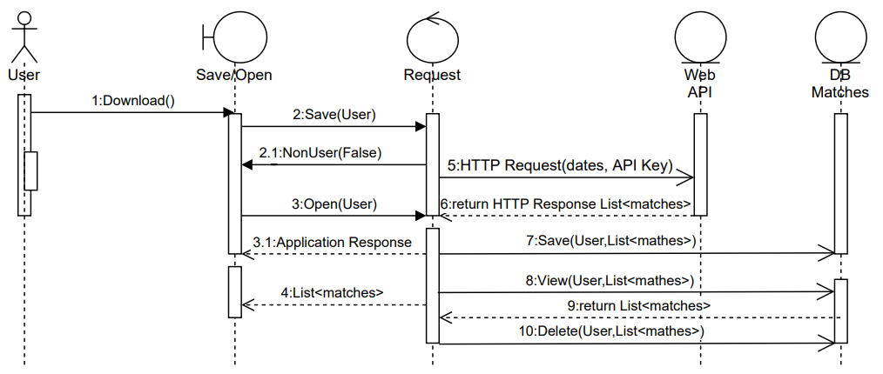

**Figure 9. User Save/Open Sequence Diagram**

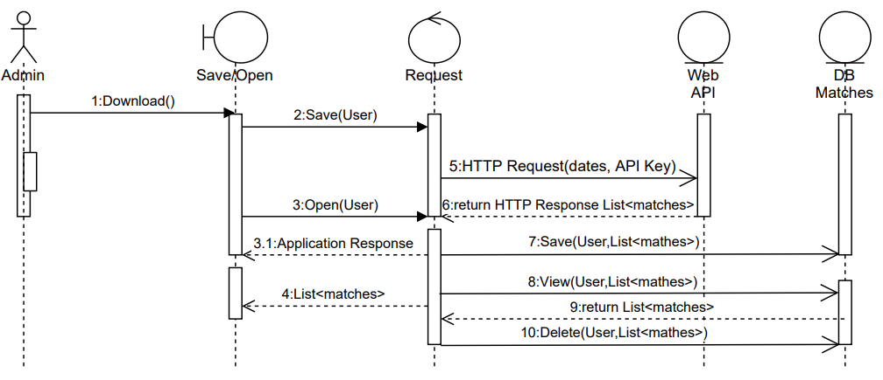

**Figure 10. Admin Save/Open Sequence Diagram**

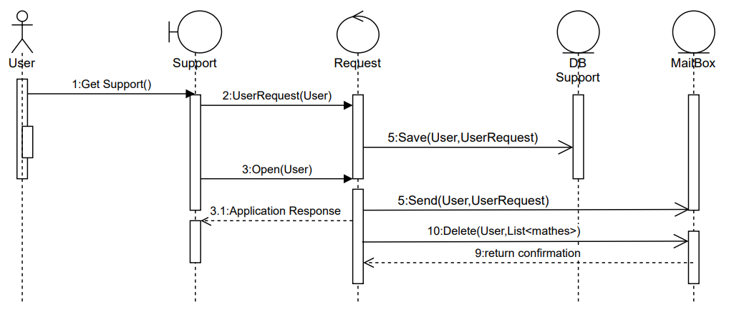

**Figure 11. User Support Sequence Diagram**

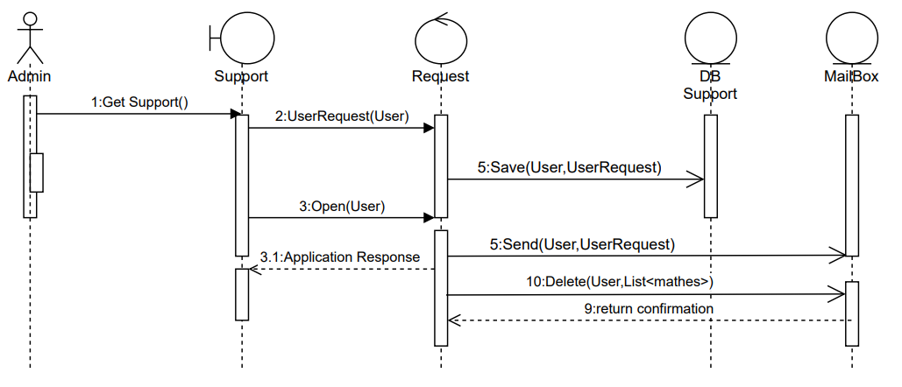

**Figure 12. Admin Support Sequence Diagram**

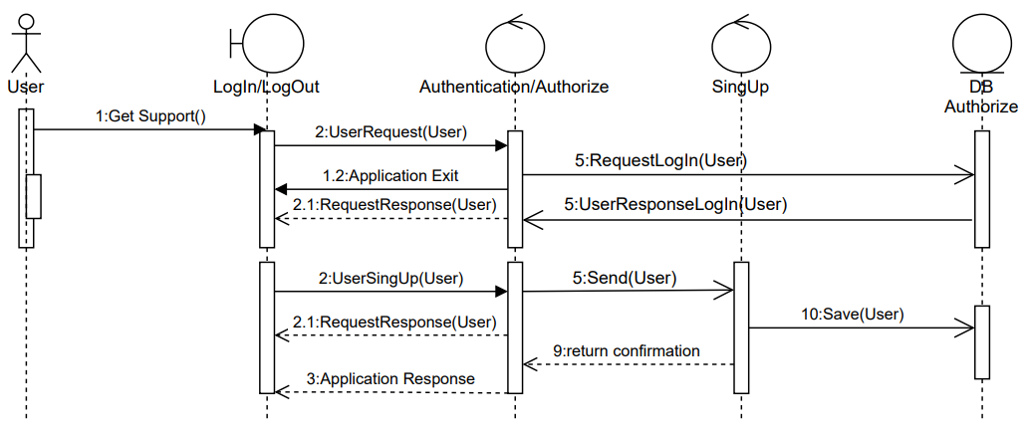

**Figure 13. User LogIn/LogOut Sequence Diagram**

# 13. EERD and UML Diagrams

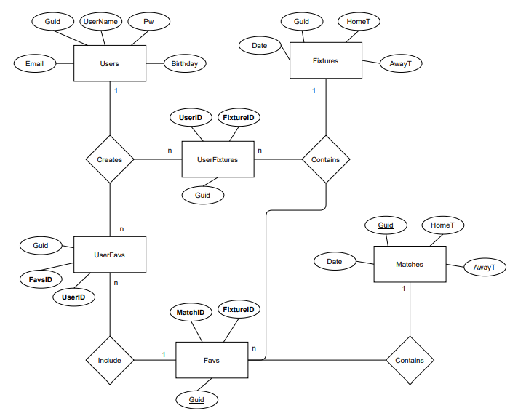

**Figure 14. EER Diagram**

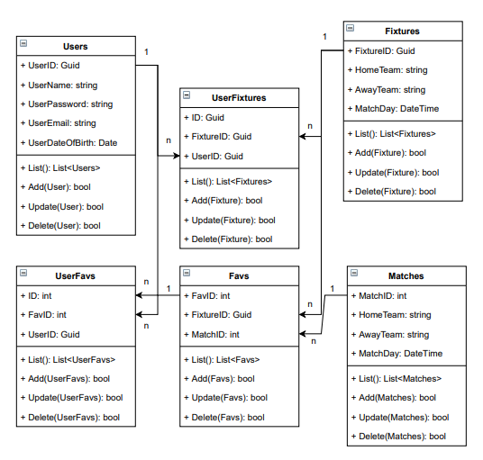

**Figure 15. UML Class Diagram**

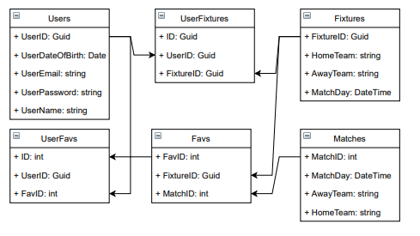

**Figure 16. UML Entity Diagram**